**GC Log Analysis after Performance Tuning:**

After comparing the GC logs of server before and after tuning it shows after optimising the server the throughput has improved. Also the full GC pauses have reduced from 3 to 1 pause for each test. The duration for each pause has reduced as well.

|  |  |  |  |  |  |  |  |  |  |  |
| --- | --- | --- | --- | --- | --- | --- | --- | --- | --- | --- |
| Configuration | Users | Footprint | Freed Memory | Freed Mem/Min | Acc pauses | Throughput | Number of full gc pauses | Full GC Performance | Number of gc pauses | GC Performance |
| Before Tuning | 50 | 343.8 M | 3161.4 M | 439.575 M/m | 3.27s | 99.24% | 3 | 17.1 M/s | 30 | 1537.8 M/s |
|  | 100 | 306.8 M | 3409.4 M | 490.551 M/m | 5.5s | 98.68% | 3 | 27.3 M/s | 36 | 986 M/s |
|  | 200 | 349.8 M | 3405.5 M | 442.835 M/m | 4.37s | 99.05% | 3 | 14.2 M/s | 32 | 1183.6 M/s |
|  | 500 | 350.1 M | 3534.5 M | 450.246 M/m | 5.44s | 98.85% | 3 | 9357.7 K/s | 33 | 1143.8 M/s |
|  | 1000 | 355.4 M | 3281.2 M | 118.493 M/m | 4.37s | 99.74% | 3 | 12.1 M/s | 31 | 1248.7 M/s |
|  | 2000 | 359.1 M | 3497.5 M | 352.041 M/m | 5.09s | 99.15% | 3 | 9768 K/s | 33 | 1226.1 M/s |
|  |  |  |  |  |  |  |  |  |  |  |
| After tuning | 50 | 490.7 m | 3163.3 M | 442.55 M/m | 2.73s | 99.36% | 1 | 782.5 K/s | 31 | 1303.5 M/s |
|  | 100 | 490.7 M | 3269.4 M | 503.06 M/m | 2.88s | 99.26% | 1 | 733.6 K/s | 32 | 1275.7 M/s |
|  | 200 | 490.7 M | 3407.8 M | 480.597 M/m | 3.37s | 99.21% | 1 | 647.2 K/s | 33 | 1137.7 M/s |
|  | 500 | 490.7 M | 3416.6 M | 414.337 M/m | 3.21s | 99.35% | 1 | 480.6K/s | 33 | 1251 M/s |
|  | 1000 | 490.7 M | 2061.9 M | 2321.72 M/m | 2.61s | 95.10% | 1 | 876 K/s | 21 | 877.1 M/s |
|  | 2000 | 490.7 M | 3239.2 M | 375.418 M/m | 3.32s | 99.36% | 1 | 493.1 /s | 32 | 1205.5 M/s |

We have attached below some screenshots from GC Viewer for different loads for all configurations

**Scenario: Performance test for 50 Users before tuning**

Figure : GC Graph

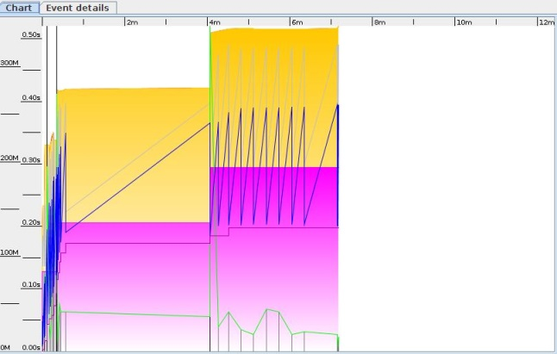

Figure : Summary

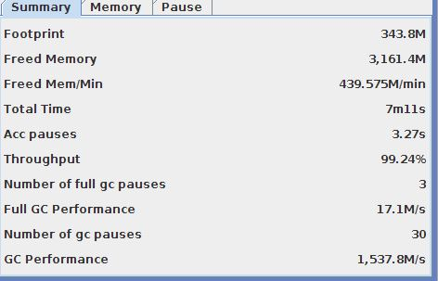

**Scenario: Performance test for 100 Users before tuning:**

Figure : GC Graph

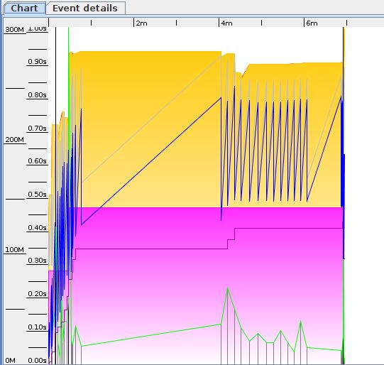

Figure : Summary

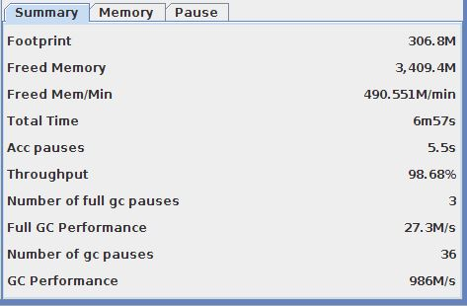

**Scenario: Performance test for 200 Users before tuning:**

Figure : GC Graph

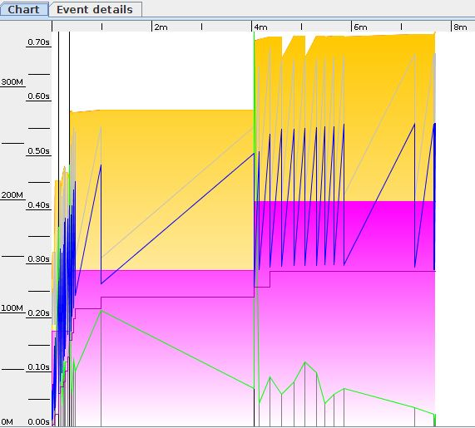

Figure : Summary

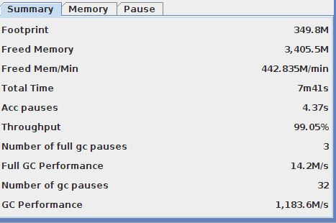

**Scenario: Performance test for 500 Users before tuning:**

Figure : GC Graph

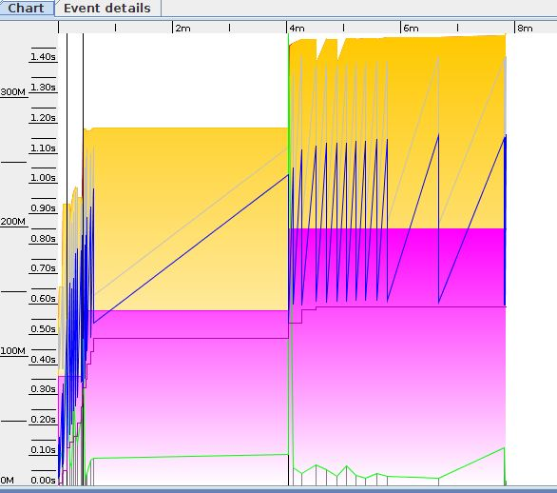

Figure : Summary

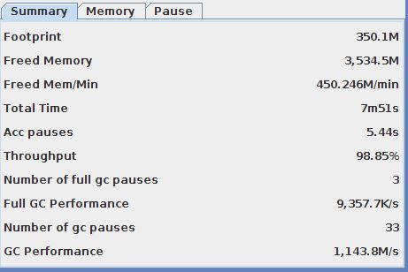

**Scenario: Performance test for 1000 Users before tuning:**

Figure : GC Graph

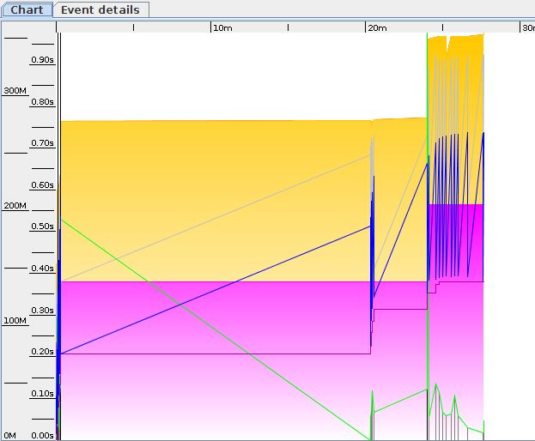

Figure : Summary

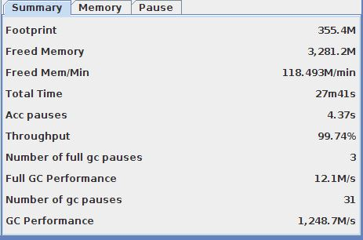

**Scenario: Performance test for 2000 Users before tuning:**

Figure : GC Graph

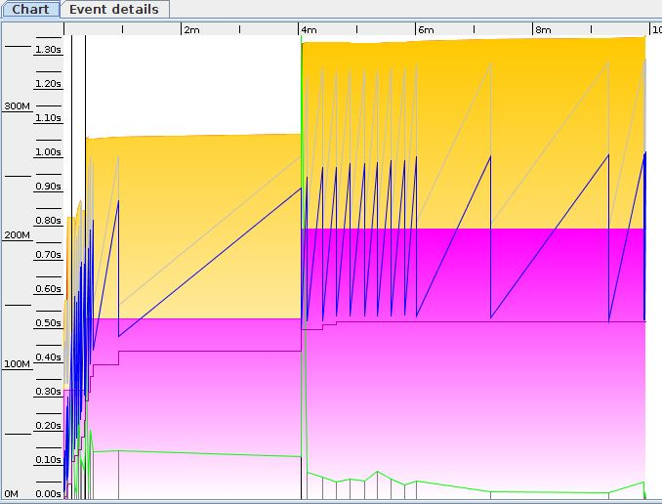

Figure : Summary

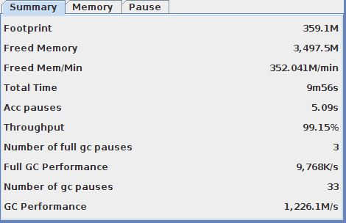

**Scenario: Performance test for 50 Users after tuning:**

Figure : GC Graph

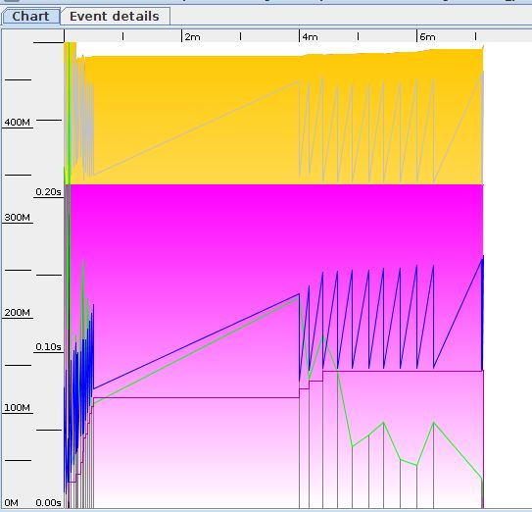

Figure : Summary

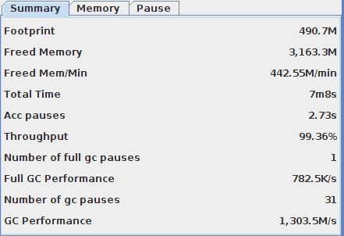

**Scenario: Performance test for 100 Users after tuning:**

Figure : GC Graph

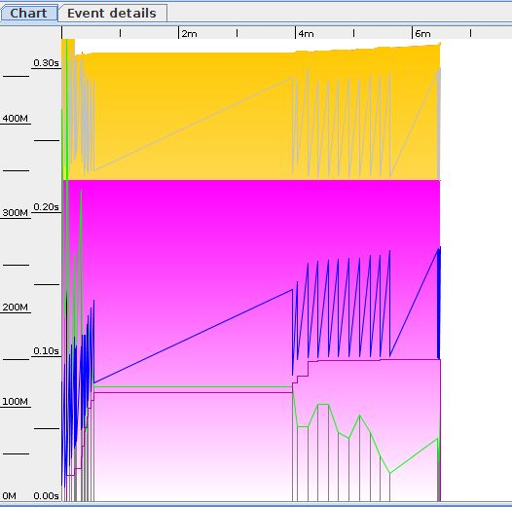

Figure : Summary

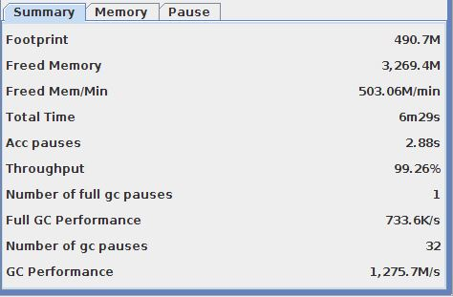

**Scenario: Performance test for 200 Users after tuning:**

Figure : GC Graph

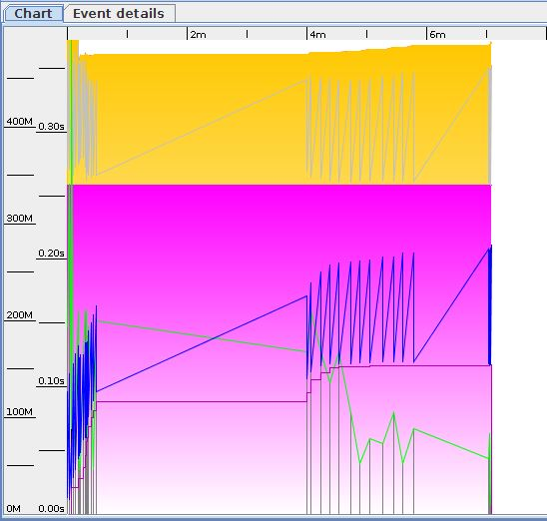

Figure : Summary

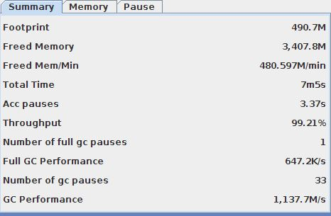

**Scenario: Performance test for 500 Users after tuning:**

Figure : GC Graph

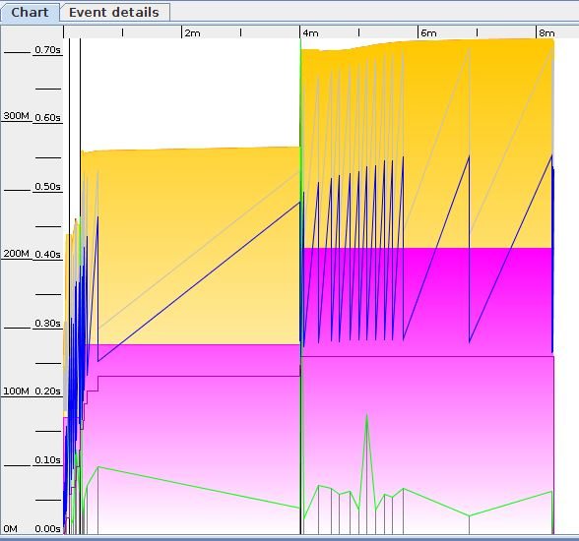

Figure : Summary

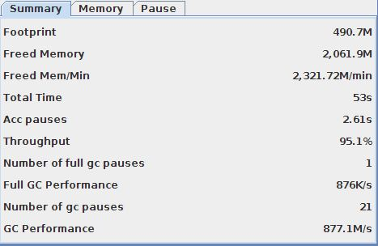

**Scenario: Performance test for 2000 Users after tuning:**

Figure : GC Graph

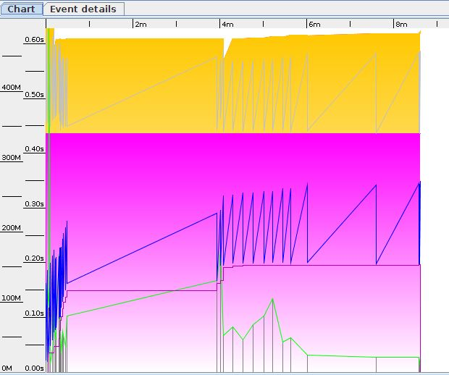

Figure : Summary

